Name: ______________________________________________ Date: ____________________ Period: __________
REVISED Study Guide: Climate Change, Seasons & Dinosaur Extinction
TEST: MONDAY, NOVEMBER 24, 2014

- List (3) causes & effects of climate change. Give detailed explanations of the process leading from the cause to the effect.
- Burning of fossil fuels: releases greenhouse gases (CO₂) into the atmosphere which traps heat near Earth’s surface increasing Earth’s average global temperature leading to…rising sea levels due to melting polar ice caps
- Car Exhaust/Emissions: releases greenhouse gases (CO₂) into the atmosphere which traps heat near Earth’s surface increasing Earth’s average global temperature leading to…changes in weather patterns producing more severe weather
- Factory Emissions: releases greenhouse gases (CO₂) into the atmosphere which traps heat near Earth’s surface increasing Earth’s average global temperature leading to…changes in precipitation changing crop production in some areas
- Deforestation: increases CO₂ in the atmosphere because the trees that remove CO₂ are gone leaving excess CO₂ which traps heat near Earth’s surface increasing Earth’s average global temperature leading to…droughts
More Effects: changing ocean currents, animal extinction, forest fires, droughts, lack of food supplies, flooding
- Draw & label a diagram of the changing seasons. Explain why the temperatures are what they are for each season. Include the date each season starts.
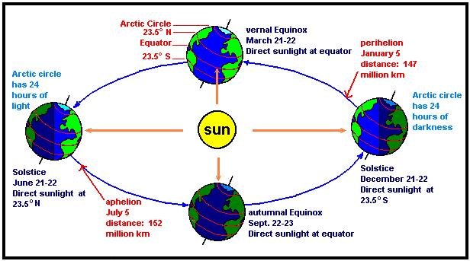
- Explain the difference between ROTATION & REVOLUTION. How are they associated with the Earth?
Rotation: the Earth spinning around its axis
Revolution: the Earth travels in a path or orbit around the Sun

- Explain the diagrams below.
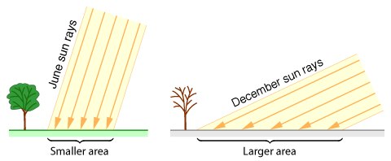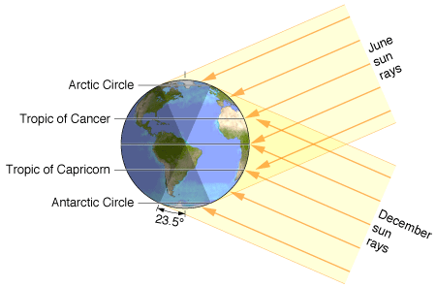
In the summer the Northern Hemisphere receives more direct/concentrated sunlight making it warmer. In the winter the angle is greater and the same amount of light is spread over a larger area giving cooler temperature.
- List the (4) hypotheses that scientists believe may have caused dinosaur extinction. Give at least one piece of evidence used to support each hypothesis.

SEE THE “HYPOTHESIS SUPPORT” PAGE ON THE WEEBLY SITE BELOW THE STUDY GUIDE LINK

- Decribe TEMPORARY Climate Change that may have led to dinosaur extinction.
Asteroid Impact & Volcanic Eruptions caused temporary climate changes when the dense cloud of dust and smoke or ash blocked sunlight decreasing temperatures killing vegetation (and therefore some animals) until the particles settled out of the atmosphere.

