Name: _____________________________________________________ Date: __________________ Period: ______
Study Guide: Cells & Mitosis
TEST: FRIDAY, OCTOBER 11, 2013
- Match the following terms & definitions. Draw a line from the term to the definition.
- A network of membranous canals filled with fluid. CELL THEORY I
They carry materials throughout the cell. This is the
"transport system" of the cell. ENDOPLASMIC RETICULUM
- They can store materials such as food, water, sugar, ORGANELLE J
minerals and waste products. VACUOLE
C. A structure inside the nucleus where RNA is made NUCLEOLUS
D. a body structure that works to perform a specialized CELL MEMBRANE L
function. Examples include the lung or heart. ORGAN
E. A large number of cells that work together to perform
a specific function. TISSUE CYTOPLASM H
F. Shaped like a bean, this cell organelle helps take food
and manufacture energy from it. Also called the
“powerhouse” of the cell. MITOCHONDRIA RIBOSOME O
G. stacks of flattened membranes that temporarily
store protein which can then leave the cell through
vesicles pinching off from this structure GOLGI BODY NUCLEUS M
H. A jelly-like substance composed mainly of water,
is constantly moving and is where the organelles CELL WALL N
are found. CYTOPLASM
- A basic principle of biology that states that cells TISSUE E
are the basic unit of structure and function in
living organisms CELL THEORY CHLOROPLAST K
J. The structures of the cell that carry out the
activities that keep the cell alive ORGANELLE MITOCHONDRIA F
K. This organelle is where photosynthesis
takes place. CHLOROPLAST ORGAN D
L. This encloses the cell, only allows certain
things in or out of the cell, provides protection ENDOPLASMIC
and stability CELL MEMBRANE RETICULUM A
M. The “brain” or “control center” of the cell.
It contains DNA. NUCLEUS GOLGI BODY G
N. Mostly made of cellulose, this is the tough
and rigid outer layer of plant cells. CELL WALL VACUOLE B
O. They produce proteins and can be found
individually in the cytoplasm of on rough ER. RIBSOME NUCLEOLUS C

- Name the type of cell and identify the missing organelles.
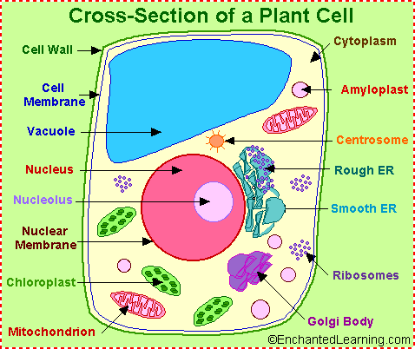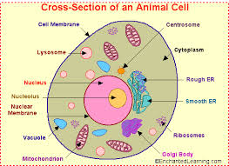

Type of Cell: __PLANT_________________ Type of Cell: _______ANIMAL________

A: ____RIBOSOMES__________________ A: ________NUCLEUS______________

B: ____VACUOLE___________________ B: _____CELL MEMBRANE___________

C: ____CELL WALL__________________ C: _____CYTOPLASM_______________

- List the 3 components of the Cell Theory (Hint: Look in your Cells Notes)
- ALL LIVING THINGS ARE MADE UP OF CELLS
- THE CELL IS THE BASIC UNIT OF STRUCTURE
- ALL CELLS COME FROM CELLS

- Who first dicovered cells? _______ROBERT HOOKE___________________________

- List the Cell Hierarchy in order from the cell up.
CELL TISSUE ORGAN ORGAN SYSTEM ORGANISM
- Why do cells divide or undergo Mitosis? List the 3 reasons
- REPRODUCTION
- GROWTH
- REPAIR

- Is the statement TRUE or FALSE. Circle your answer.
TRUE FALSE 1. Mitosis takes 1 hour to complete. (24 HRS)
TRUE FALSE 2. Interphase is the longest phase of the cell’s life cycle.
TRUE FALSE 3. At the end of mitosis, 1 daughter cell is produced. (2 DAUGHTER CELLS)
- Label the Diagram below.
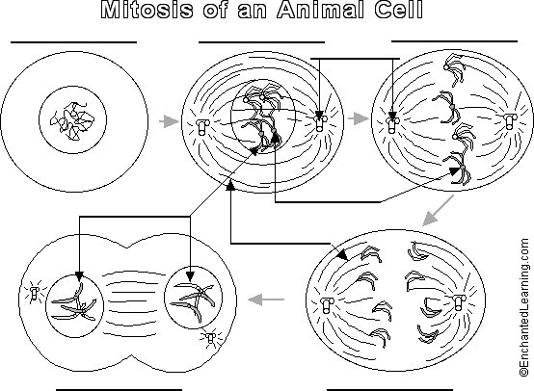
CHROMOSOMES
TELOPHASE
ANAPHASE
SPINDLE FIBERS
CENTROMERES
CENTRIOLES
METAPHASE
PROPHASE
INTERPHASE

WORD BANK FOR DIAGRAM:

TELOPHASE PROPHASE INTERPHASE ANAPHASE

METAPHASE CENTRIOLES SPINDLE FIBERS CENTROMERES

CHROMOSOMES

- Identify the stages of Mitosis from the section of onion.
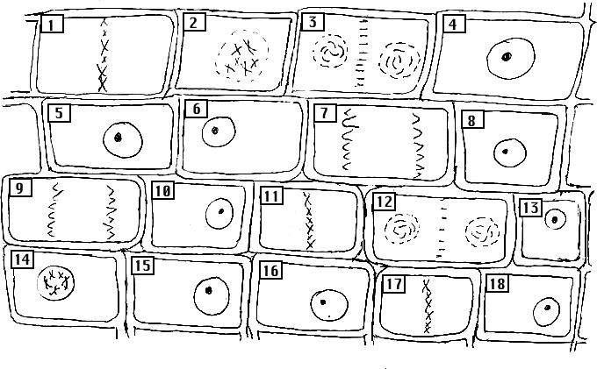
1. _____ metaphase______
2. _____ prophase________
3. _____TELOPHASE_____________
4. _____interphase______
5. _____INTERPHASE____________
6. ______interphase_______
7. _____ANAPHASE______________
8. ______interphase______
9. ______anaphase______
10. ___ interphase______
11. _____METAPHASE___________
12. _____telophase_______
13. _____interphase____
14. _____PROPHASE____________
15. ____interphase_____
16. _____INTERPHASE___________
17. _____metaphase_____
18. _____INTERPHASE___________
Which phase appears the most? ___INTERPHASE_______________________
Why do you think that phase appears the most? ___BECAUSE IT’S THE PHASE THE CELL SPENDS MOST OF ITS LIFE CYCLE IN _______

